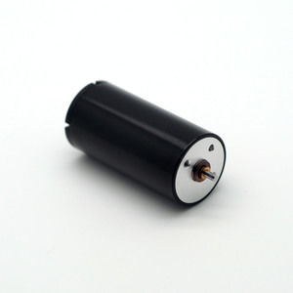

#### 22X44mm Coreless Brushed Series

**SPECIFICATIONS:**

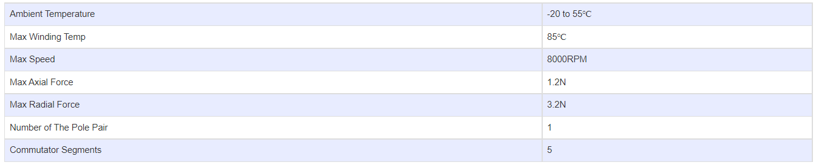

**SUBMODELS:**

*The following are common submodels for the LDO-CL2244 series.*

